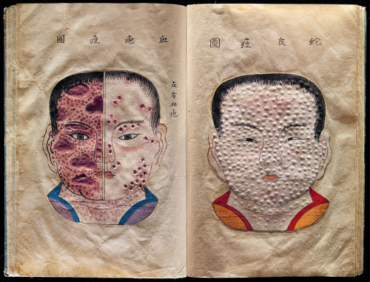
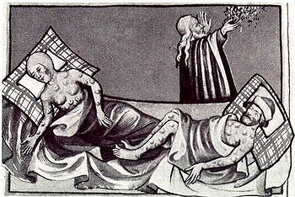
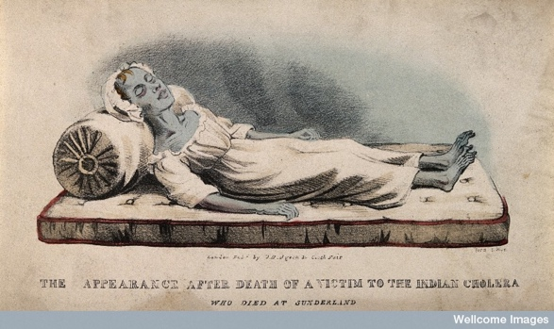
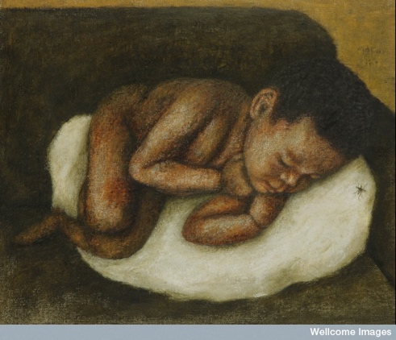
C
A
B
D
Cholera –
- Pale bluish Skin, Dehydration, Fatigue, Sickness, Fever,

Malaria –
- Red spots, Fever, Fatigue, Vomiting, Shivering, Sweats

Black Death (Plague) –
- Chest Pain, Fever, Sweats, Coughing up Blood, Vomiting, Large lumps and growths about the size of an orange which oozed Blood and Pus.

Smallpox –
- Fever, Aches and Pains, Headache, Fatigue, Vomiting, Small red spots which ooze clear fluid and then scab over.
On your sheets – Match the Disease to the Symptoms

